Project Activity Report-2

Project Title: “Build a GNU/Linux Distribution”

Team members: Faculty Guide:

Arpan Chavda (09bce006) Dr. Sanjay Garg

Hitesh Piprotar (09bce054) Computer Sci. & Engg. Department



Duration: 23/1/2013 to 8/2/2013

* We are developing two Linux distributions.

1) DMLinux

2) Open Gujarat

* DMLinux stands for developers’ mono Linux. It is developed for students, coders, software engineers, developers which help them in their everyday work.
* OpenGujarat is for the students of entire Gujarat state. It is completely in regional language.

**Requirement Analysis**

* To develop this system we have taken review about what to include in system means which IDEs, multimedia apps,utilities softwares, programming tools, emulator tools and all these stuff they want that will really helpful for developers and students.

**Design Diagrams**

* We have made Gantt chart for entire project schedule.
* We have made system diagram of our operating system.

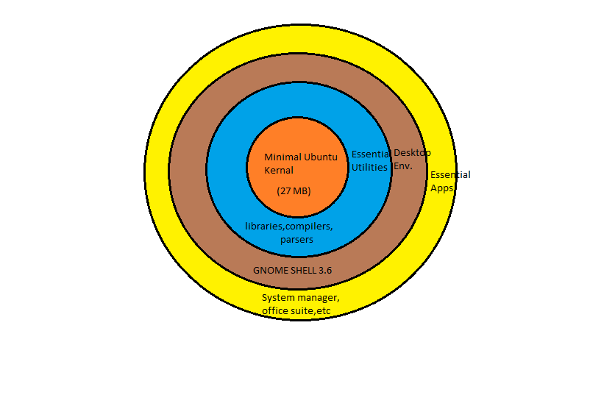**System Development**

* First we have downloaded minimal Ubuntu disk from Ubuntu.com which contains basic kernel with some other utilities. We have also configured system locale and keyboard.
* We have downloaded tarballs of apt, python and for some other libraries. It is still command line and still there is no GUI.
* Then we have chosen GNOME Shell desktop environment for our DMLinux which is more user friendly then other DE.
* Then we have changed system files using several tools and some utilities which are as follows.

-chroot

-uck(Ubuntu Customization Toolkit)

-package management toolkits

-dconf and gconf editors

-init.d scripts